**Sourdough Rye Bread**

By: Alec Meyer

It seems that everyone in this quarantine has taken up a new hobby, whether it's some new craft, a new instrument, binging TV shows, or cooking. I am writing to cater to all those who have decided to pursue their dreams of becoming an at-home professional chef during quarantine. My goal is to help add a new exciting recipe to your arsenal, sourdough rye bread. I have noticed a surge in sourdough and creating your sourdough starters, so this recipe will be perfect for those who have made their starters or have just picked them up from the store. With this recipe, you will taste the earthiness from the rye and the tang from the sourdough. It will combine into the perfect bread for anything from breakfast to the perfect sandwich. These instructions will also teach you the science behind sourdough and how bread becomes bread. Let's get baking!

**Ingredients:**

* 1 cup active sourdough starter
* 1 1/2 cups warm water
* 1 cup stone ground rye flour
* 2 1/2 cups bread flour
* 1 tablespoon malt syrup
* 2 teaspoons table salt
* 1 egg white
* ½ cup corn meal
* 2 bread pans
* Kitchen knife/bread scraper
* Stand mixer with bread hook and paddle (optional)

**What is Sourdough?**

Sourdough or sourdough starter is a way to create yeast for your bread instead of buying your usual yeast packets. The way it works is when flour and water are mixed, they develop great nutrients for yeast microbes to feast on and multiply. This fermentation period produces lactic and acetic acids, which gives sourdough bread its notoriously “sour” taste. We will not be creating our sourdough starter in these instructions, but it is something that many people do and is a great way to make this recipe just a bit more your own.

**Step 1: Feeding the Yeast**

To start things off, in our stand mixer or large bowl, we will want to add our 1 ½ cups of warm water, 1 cup of rye flour, and 1 cup of bread flour. Using our paddle attachment on our stand mixer, you will stir this mixture until It forms a thick batter and you do not see any large chunks of flour. Once the batter has formed you will cover the bowl with either a washcloth or plastic wrap for about 45 minutes to an hour. This step initiates the yeast by giving it water and flour as nutrients.

**Step 2: Kneading the Dough**

You will need to first switch out the paddle attachment on your stand mixer to your dough hook attachment for the second step. Uncover the batter you had from the previous step and add in your tablespoon of malt syrup. The malt syrup is going to moisten and lightly sweeten your bread. You will also add your 2 teaspoons of salt. Begin stirring your bread using the stand mixer or by hand while adding ¼ cups of flour at a time. Keep adding flour until the mixture no longer sticks to the bowl. Once you have mixed it well, the dough should be completely stuck to the hook. Take the dough off the hook, place it on a floured surface, and begin kneading the dough. A trick to kneading the dough effectively is by making sure you push the dough and fold it over, as shown in **Figure 1**, as it will help disperse all of the ingredients throughout the dough. You will want to knead the dough until it is smooth, usually taking around 7 minutes, but it is essential to make sure the dough is soft before moving onto the next step.

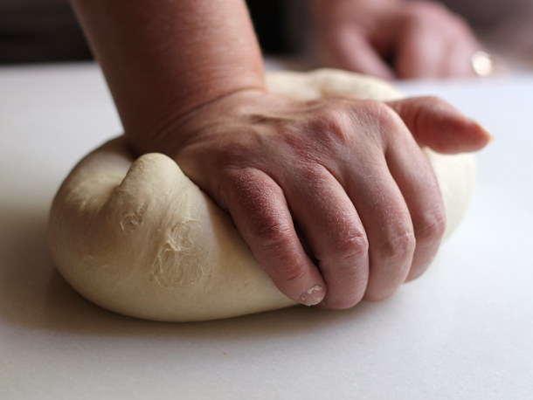

Figure 1, “Kneading Dough,” Currie, August 13, 2012

**Step 3: Letting the Dough Rest**

Once you have kneaded your dough, you will need to place it in a lightly oiled large bowl. For the next hour, in 20-minute intervals, you will want to fold the dough over in the bowl as shown in **Figure 2;** this will help distribute the yeast evenly. After the hour of folding dough, you will want to cover the bowl with plastic wrap or a washcloth like you had done before to allow it to rise for about 1 ½ to 2 hours. After you let the dough rise, you are going to want to punch the dough. This isn’t the most necessary step, but it’s an excellent way to relieve any pent-up aggression! Once you have let out your anger, you’ll want to start kneading the dough, as I had explained earlier. Keep kneading the dough until it feels elastic, and when you poke your finger into it, there should not be an indent left behind. If you are struggling to obtain this texture, you’ll want to cover the dough again and let it sit in a covered bowl for another hour or so and repeat the kneading process. Once your dough is the correct consistency, you will want to place it back into a covered bowl and place it in the refrigerator for 8 to 10 hours (or overnight). The reason we are kneading the bread so much is to add gluten to the dough. The gluten will then help yeast production, causing the bread to rise even more once it is settling in a bowl.

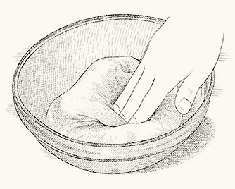

Figure 2, “Folding Dough in Bowl,” Cooks Illustrated, 2021

**Step 4: Preparing the Dough**

Once your dough has been in the refrigerator for around 8 to 10 hours, you will want to take it out. Placing the dough in the refrigerator is to slow down the production of yeast, which will add flavor to the bread. Next, you will need to split the dough into two pieces as it is too large to cook. The best way to do this is by taking a large kitchen knife or a bread scraper and just quickly slicing the dough in half. Take one piece of your now cut dough and begin kneading it into a smooth ball like **Figure 3**. The way to achieve this smooth ball look will be by constantly folding the bread's sides under itself. This will cause the bottom of your bread ball to ideally look like **Figure 4**. Repeat this process on your other section of dough. Once both doughs are ready, you will need to cover the bottoms of two bread-pans with a liberal amount of cornmeal. The cornmeal is used to help the bread from sticking while also adding some flavor and texture. When each section of dough is placed in their cornmeal-covered bread-pans, you will want to, for the last time, cover each loaf and let sit until both have doubled in size, which usually takes about an hour. Once you have about 15 minutes left to rise, you will want to preheat your oven to 425°F.

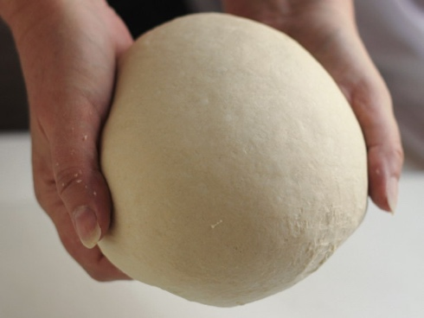

Figure 3, “Smooth Dough,” Currie, August 14, 2012

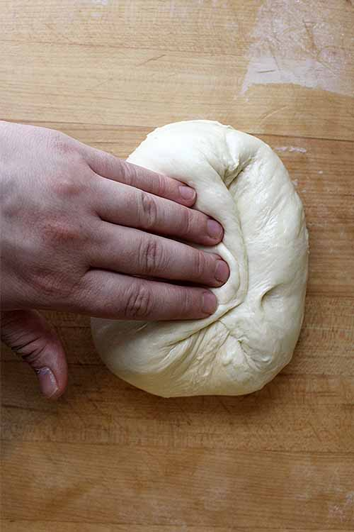

Figure 4, “Underside of Smooth Dough,” Vanderslice, September 6, 2016

**Step 5: Baking**

Once your two pieces of bread dough have finished doubling in size, it is time for you to add some personal touches to the bread. You are going to need to slice the top of the dough to allow it to expand uniformly. I have seen many people make an art out of this. You can either take the route of a single cut down the middle or create your masterpiece like **Figure 5**. Once your dough is scored, you will then place it into your already preheated oven. The dough should take around 35 minutes until it is ready to take out or until it sounds hollow when you tap it with a knife. Once the bread is out of the oven, you will need to wait for it to cool as it is still in its cooking process (I know it’s tempting to cut into it right away, but I can say from experience that’s one of the best ways to ruin your hard-earned progress). Once your bread’s surface has cooled to around room temperature, you can take it out of the bread pans and start slicing!

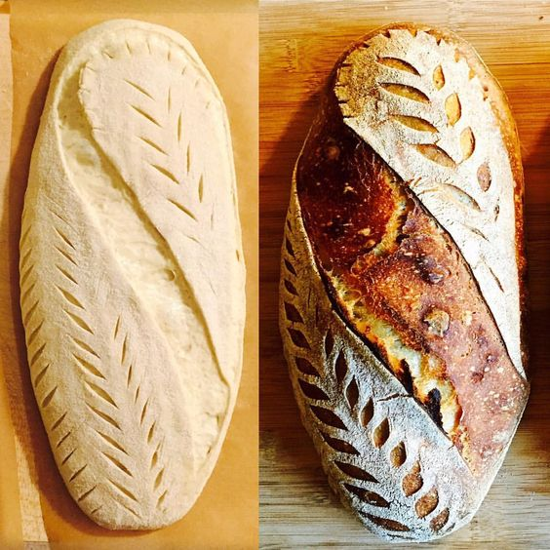

Figure 5, “Bread Scoring Masterpiece,” Carthy, April 5, 2016

**Conclusion**

Making your bread is a great way to get your foot in the door for cooking and baking. It is straightforward but takes some finesse to get right. Making bread is also extremely modular as there are a plethora of ways to bake bread. One way you could take this recipe and push it just a little bit further could be by making your sourdough starter. This is another whole process on its own, so it was not covered in these instructions. I hope all of you, new and experienced chefs, learned something from this tutorial and have another way to pass the time during these strange times.

**Work Cited:**

# Bernstein, Max. “The Science of Baking Bread (and How to Do It Right)” *Serious Eats,* October 15, 2014, <https://www.seriouseats.com/2014/10/breadmaking-101-the-science-of-baking-bread-and-how-to-do-it-righ.html> Accessed February 23rd, 2021

Currie, Donna. “Bread Technique: Folding the Dough” *Serious Eats,* August 14, 2012,

# [*https://www.seriouseats.com/2012/08/the-art-of-baking-breads-folding-technique.html*](https://www.seriouseats.com/2012/08/the-art-of-baking-breads-folding-technique.html) *Accessed February 25th, 2021.*

# Gray, Eileen. “Sourdough Rye Bread” *Baking Sense*, January, 2020, <https://www.baking-sense.com/2019/08/01/sourdough-rye-bread/> Accessed January 2020

# Holmes, Bob. “The Science of Sourdough: How Microbes Enabled a Pandemic Pastime” *Scientific American,* August 13, 2020, <https://www.scientificamerican.com/article/the-science-of-sourdough-how-microbes-enabled-a-pandemic-pastime/> Accessed February 23rd, 2021

# Meyer, Alec. *Sourdough Rye Bread Recipe*, 2020